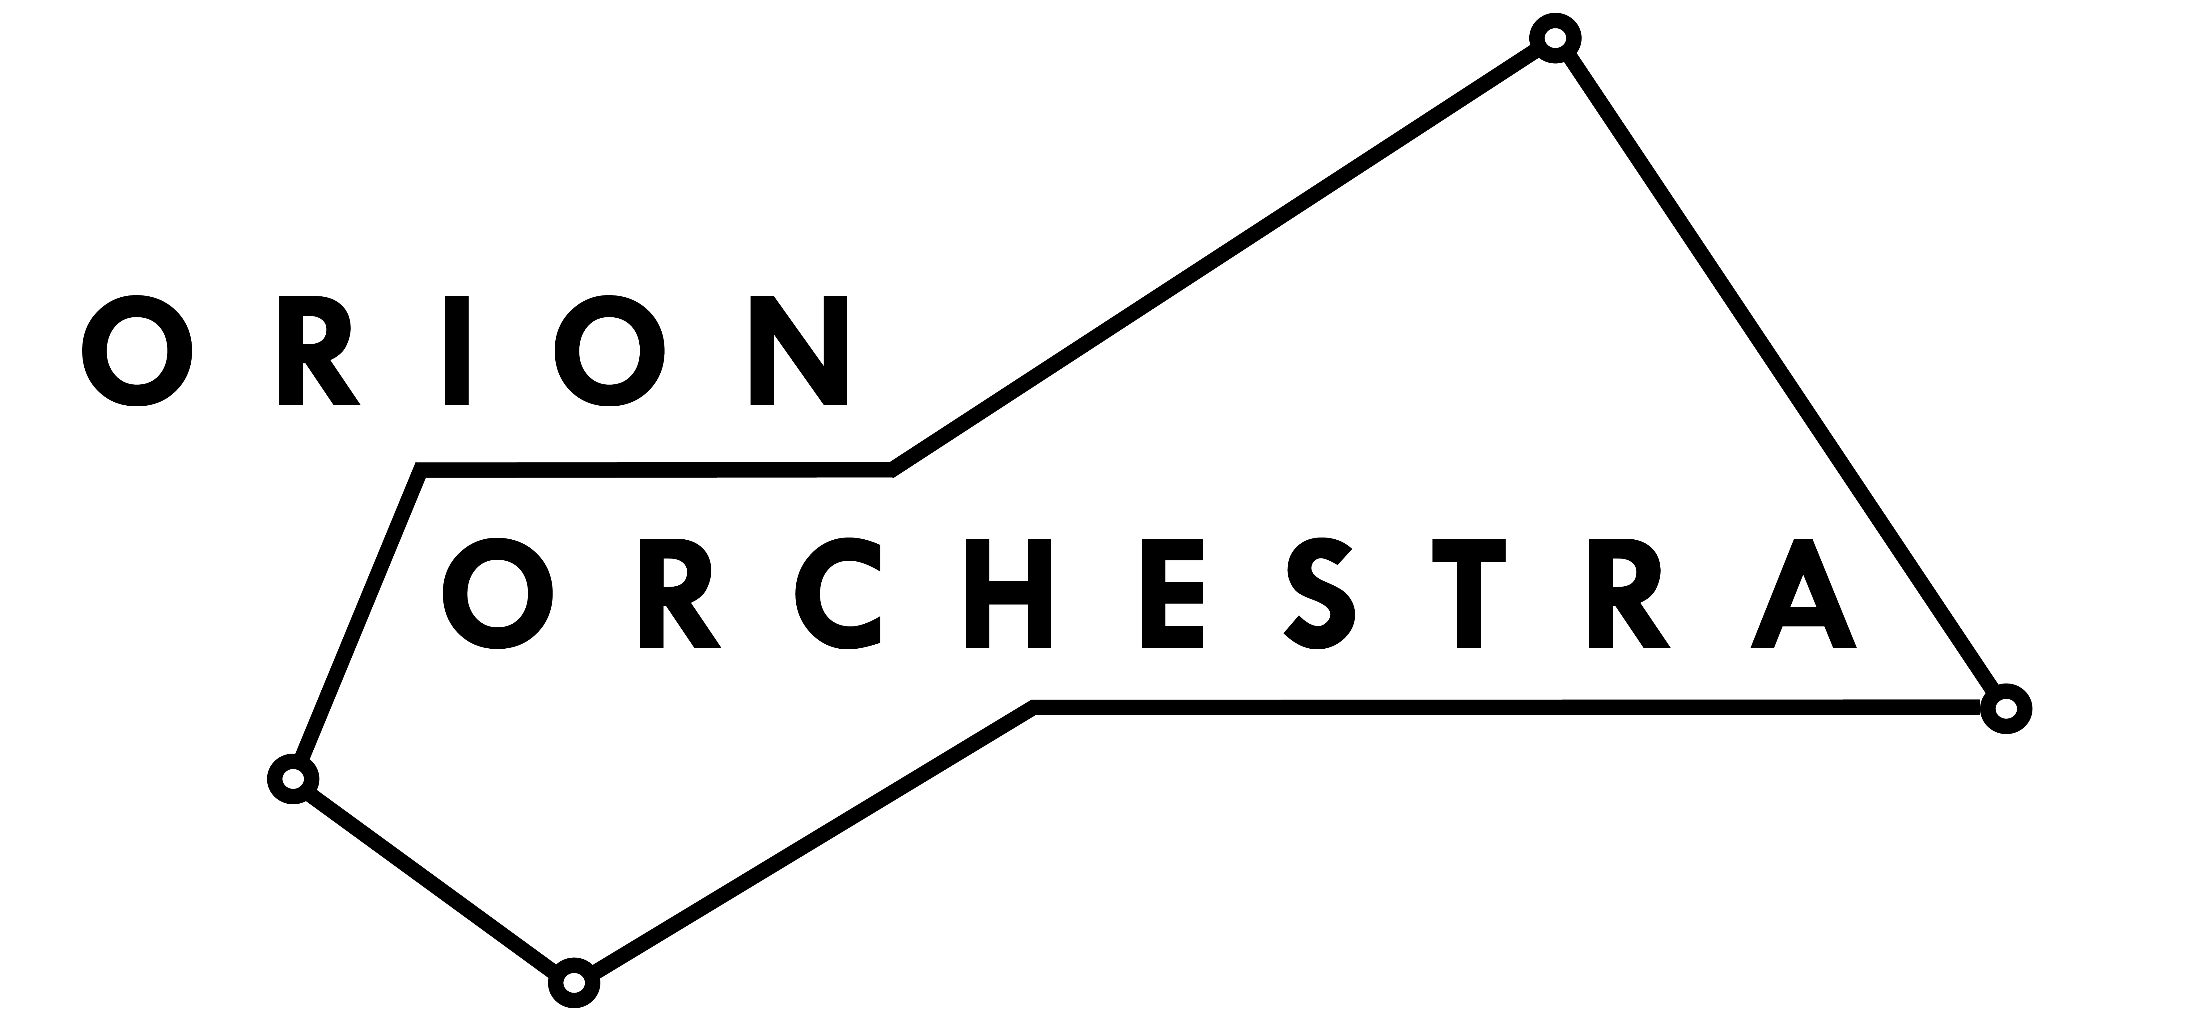
ORION COMPOSITION
COMPETITION 2017
in association with Dyson
APPLICATION FORM

Once completed either digitally or by hand, please return this form to max@orionorchestra.org.uk or by post to: FAO Orion Composition Competition, 38a Fenwick Road, London SE15 4HW. Unfortunately we are unable to return any materials submitted via post. The deadline is midnight, 20th October 2017.

Surname:
First Name(s):
Telephone:
Address:

Submission of previous work. Please provide details for the two pieces of previous composition work attached as part of your application. Audio files may be attached via an existing link or media file, or larger files sent to max@orionorchestra.org.uk via https://wetransfer.com/

Piece #1 (title/date of composition):
Please answer here…
Have you attached a recording of this piece? YES / NO

Piece #2 (title/date of composition):
Please answer here…
Have you attached a recording of this piece? YES / NO

Have your compositions been performed in public before?
If so, please give details of two recent performances.
Please answer here…
What is your current occupation?
If you are a student, please tell us where and what your studies are.
Please answer here…

What motivated you to approach this commission in particular?
Please answer here…

Please outline your approach to the commission. Give detail of your concept, instrumentation, and how it would respond with the competition’s creative brief.
Please answer here…
Continued…

